

American International University Bangladesh

**INTODUCTION TO DATABASE**

**PROJECT**

**Section: D**

**GROUP: VELVET**

**Project Title:** RESTUARENT MANAGEMENT SYSTEM

|  |  |  |
| --- | --- | --- |
| **SL.**  **NO.** | **STUDENT NAME** | **STUDENT ID** |
| **01.** | **KAZI SHAFAT NAWAZ** | **19-41256-3** |
| **02.** | **NAZIA HASSAN** | **19-41259-3** |
| **03.** | **MD.TAHMID ISLAM BHUIYAN** | **19-41271-3** |
| **04.** | **FAIYAZ KHONDAKAR** | **19-41326-3** |

**Index**

1. Overview ……………………………………………………………………….3
2. ER Diagram …………………………………………………………………….4
3. Normalization …………………………………………………………………5-8
4. Table description……………………………………………………………..9-12
5. Table row insertion………………………………………………………….13-16
6. Questions…………………………………………………………………………16-20
7. Summarization…………………………………………………………………21

***Overview:***

Restaurant management system is a database management system for a basic restaurant. This project is developed by using SQL. Basically, in this system the service provider can operate and hold all the information for daily service very efficiently. Furthermore, it contains many information like customer’s identity, name, service list, menu and price which helps for customer to choose desired food for them easily. With those data restaurant management can sort customer and can value higher priority customers. Also, bill id and dates can be used to check individual day’s earnings. Moreover, they can provide different types of offer for different costumer by their priority. Lastly, it helps to track how many services a stuff member provided.

**ER Diagram**

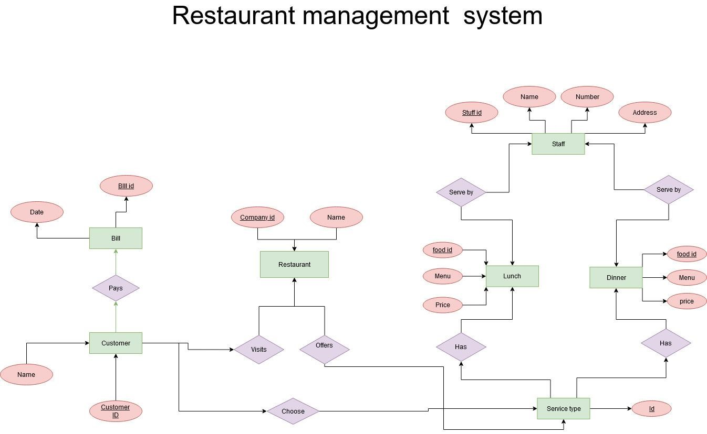

Normalization:

**Pays**

**1NF**

No multi valued attribute.

1. Bill_id, Date, Customer_id, Name

**2NF**

1. Bill_id, Date
2. Customer_id, Name

**3NF**

There is no transitive dependency

1. Bill_id, Date
2. Customer_id, Name,

**Table creation**

1. Bill_id, Date
2. Customer_id , Name, **Bill_id**

**Visit**

**1NF**

No multivalued attribute.

1. Customer_id , Name, Company_name, Company_id

**2NF**

1. Customer_id , Name
2. Company_name, Company_id

**3NF**

There is no transitive dependency

1. Customer_id , Name
2. Company_name, Company_id

**Table creation**

1. Customer_id, Name
2. Company_name, Company_id

**Choose**

**1NF**

No multivalued attributes

1. Customer_id, Name, Service_id

**2NF**

1. Customer_id, Name,
2. Service_id

**3NF**

There is no transitive dependency

1. Customer_id, Name,
2. Service_id

**Table creation**

1. Customer_id, Name
2. Service_id, **Customer_id**

**Offers**

**1NF**

No multi valued attribute

1. Company_id, Company_name, Service_id

**2NF**

1. Company_id, Company_name
2. Service_id

**3NF**

No transitive dependency

1. Company_id, Company_name
2. Service_id

**Table creation**

1. Company_id, Company_name
2. Service_id, **Company_id**

**Has**

**1NF**

No multi valued attribute

1. Service_id, Menu, Food_id , Price

**2NF**

1. Service_id
2. Food_id , Menu, Price

**3NF**

No transitive dependency

1. Service_id
2. Food_id , Menu, Price

**Table creation**

1. Service_id
2. Food_id , Menu, Price, **Service_id**

**Has**

**1NF**

No multi valued attribute

1. Service_id, Menu, Food_id , Price

**2NF**

1. Service_id
2. Menu, Food_id , Price

**3NF**

No transitive dependency

1. Service_id
2. Menu, Food_id , Price

**Table creation**

1. Service_id
2. Food_id , Menu,Price, **Service_id**

**Serve by**

**1NF**

Number is a multi-valued attribute

1. Food_id, Menu, Price, Staff_id, Stuff_name, number, Address

**2NF**

1. Food_id, Price, Menu
2. Staff_id, Stuff_name, number, Address

**3NF**

No transitive dependency

1. Food_id, Price, Menu
2. Staff_id, Stuff_name, number, Address

**Table creation**

1. Food_id, Price, Menu
2. Staff_id, Stuff_name, number, Address, **Food_id**

**Serve by**

**1NF**

Number is a multi-valued attribute

1. Food_id, Menu, Price, Staff_id, Stuff_name, number, Address

**2NF**

1. Food_id, Price, Menu
2. Staff_id, Stuff_name, number, Address

**3NF**

No transitive dependency

1. Food_id, Price, Menu
2. Staff_id, Stuff_name, number, Address

**Table creation**

1. Food_id, Price, Menu
2. Staff_id, Stuff_name, number, Address, **Food_id**

**Temporary Tables:**

1. Bill_id, Date
2. Customer_id, Name
3. Company_name, Company_id
4. Customer_id, Name
5. Service_id, **Customer_id**
6. Company_id, Company_name
7. Service_id, **Company_id**
8. Service_id
9. Food_id , Menu, Price, **Service_id**
10. Service_id
11. Food_id , Menu,Price, **Service_id**
12. Food_id, Price, Menu
13. Staff_id, Stuff_name, number, Address, **Food_id**
14. Food_id, Price, Menu
15. Staff_id, Stuff_name, number, Address, **Food_id**

**Final tables:**

1. RESTAURANT(COMPANY_NAME, COMPANY_ID)
2. BILL(BILL_ID, DATE
3. CUSTOMER(C_ID, NAME, BILL_ID)
4. SERVICE_TYPE(SERVICE_TYPE_ID, SERVICE_TYPE, C_ID)
5. SERVICES( FOOD,F_ID,SERVICE_TYPE_ID,PRICE)
6. STAFF(STAFF_NAME,STAFF_ID,PHONE_NO, ADDRESS,F_ID)

**Table creation:**

1. CREATE TABLE RESTAURANT(

COMPANY_ID NUMBER(12) not null,

PRIMARY KEY (COMPANY_ID),

NAME VARCHAR (20) NOT NULL);

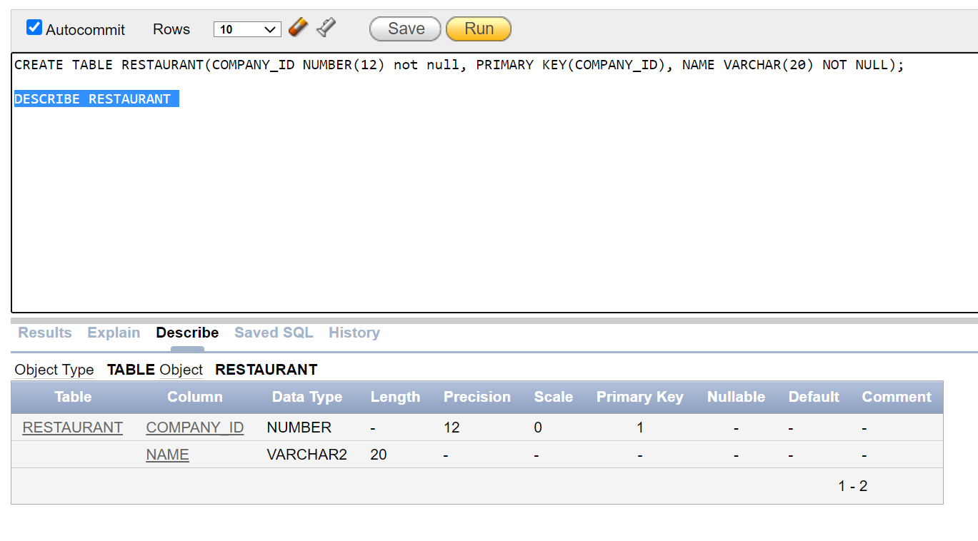

1. CREATE TABLE BILL (

BILL_ID NUMBER (10) NOT NULL,

PRIMARY KEY (BILL_ID), DATE_NO DATE);

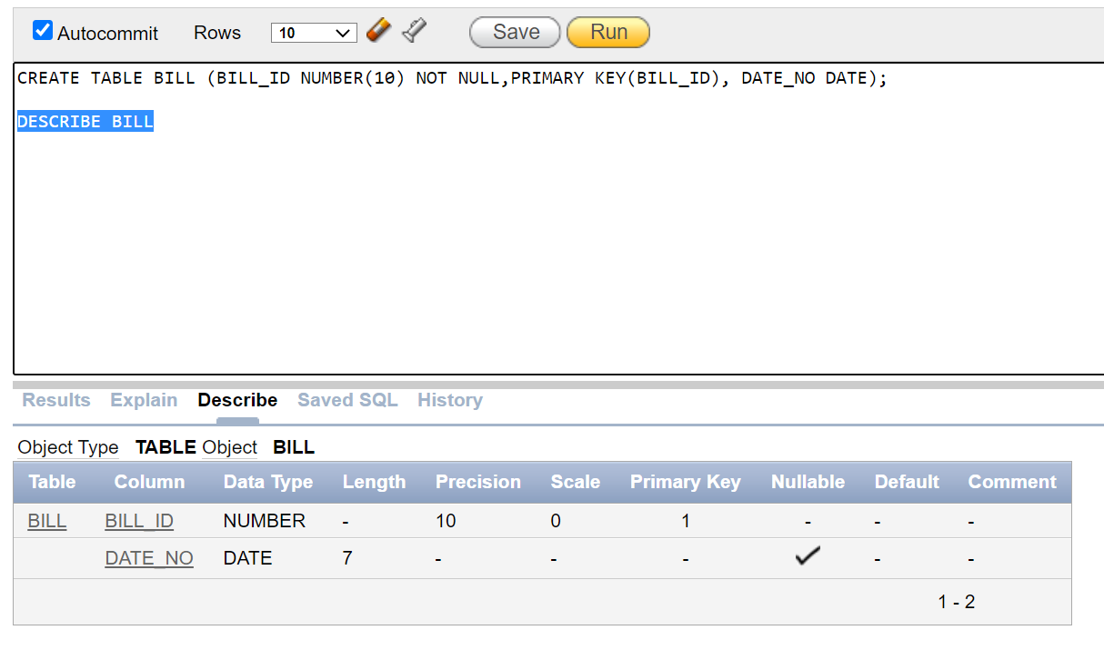

1. CREATE TABLE CUSTOMER(

C_ID NUMBER (10) NOT NULL,

PRIMARY KEY (C_ID),

NAME VARCHAR (20) NOT NULL,

BILL_ID NUMBER (10) NOT NULL,

CONSTRAINT FK_BILL_ID FOREIGN KEY (BILL_ID) REFERENCES BILL (BILL_ID));

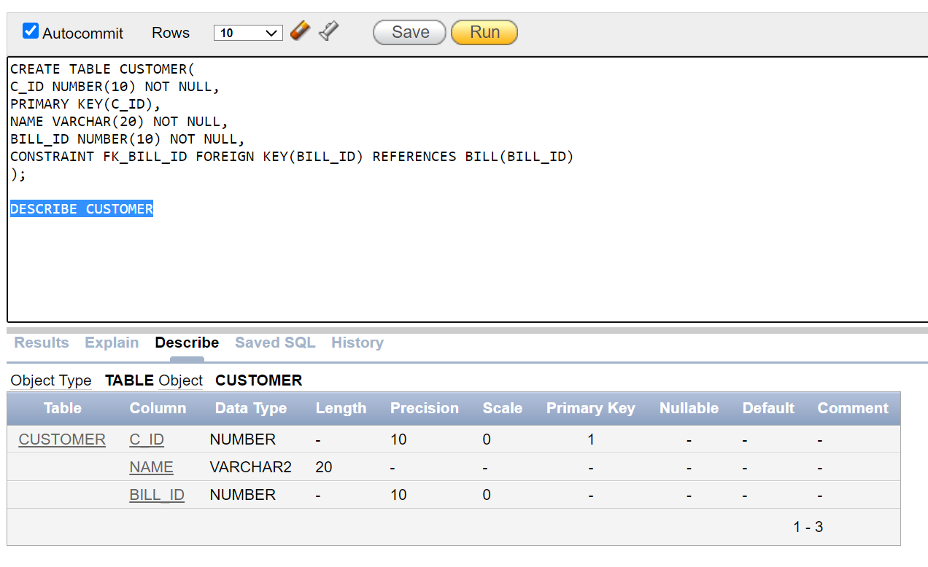

1. CREATE TABLE SERVICE_TYPE (

SERVICE_TYPE_ID NUMBER (10) PRIMARY KEY,

SERVICE_TYPE VARCHAR (10) NOT NULL,

C_ID NUMBER (10),

FOREIGN KEY (C_ID) REFERENCES CUSTOMER (C_ID))

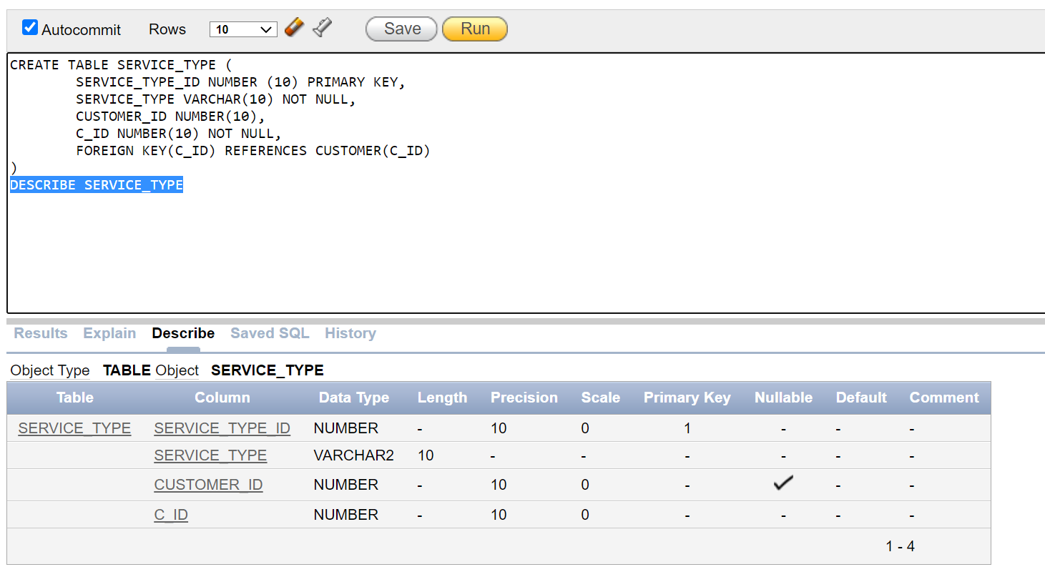

1. CREATE TABLE SERVICES(

FOOD VARCHAR (10) NOT NULL, F_ID NUMBER (10) PRIMARY KEY,

SERVICE_TYPE_ID NUMBER (10) NOT NULL, PRICE NUMBER (5),

FOREIGN KEY (SERVICE_TYPE_ID) REFERENCES SERVICE_TYPE (SERVICE_TYPE_ID));

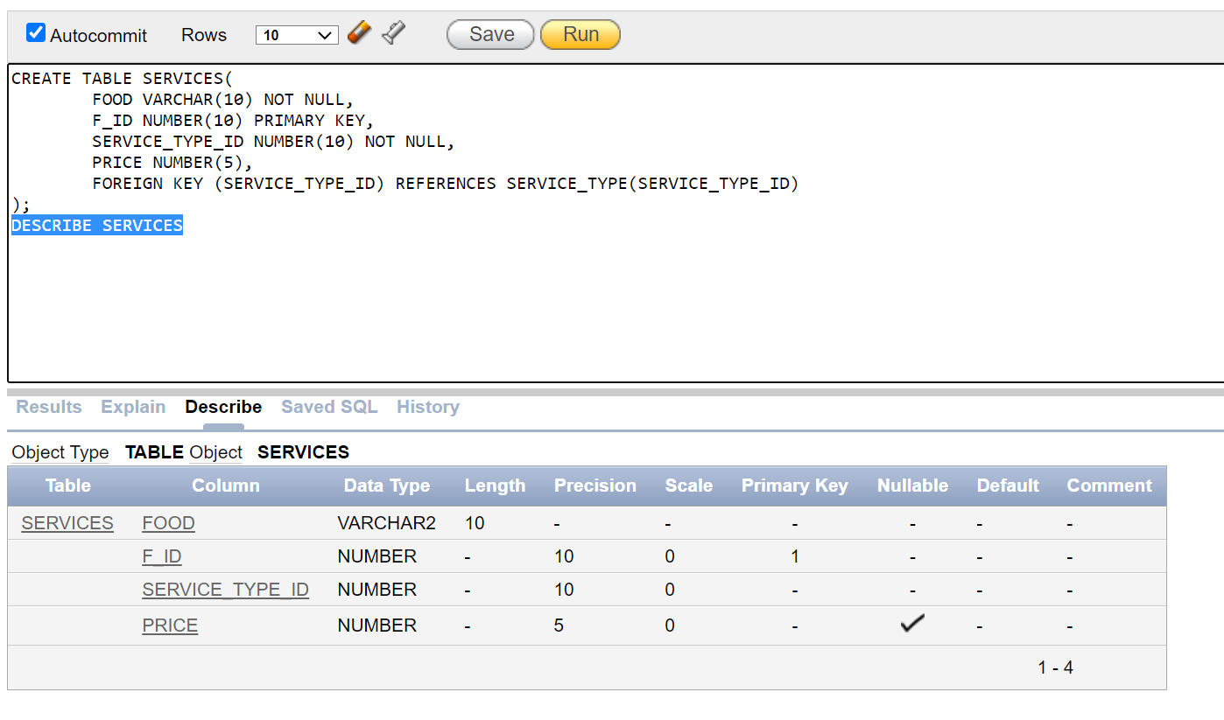

1. CREATE TABLE STAFF(

STAFF_NAME VARCHAR (20) NOT NULL, STAFF_ID NUMBER (10) PRIMARY KEY,

PHONE_NO NUMBER (11) NOT NULL, ADDRESS VARCHAR (20) NOT NULL,

F_ID NUMBER (10) NOT NULL, FOREIGN KEY (F_ID) REFERENCES SERVICES (F_ID));

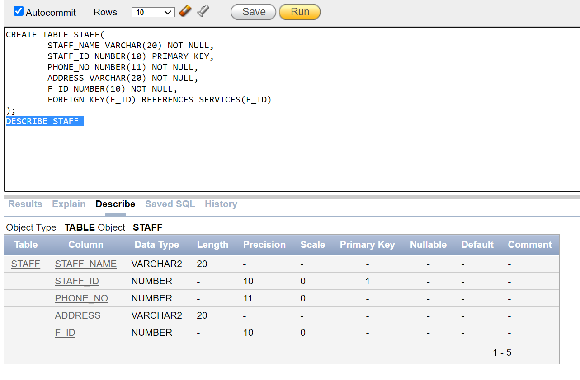

**Row insertion**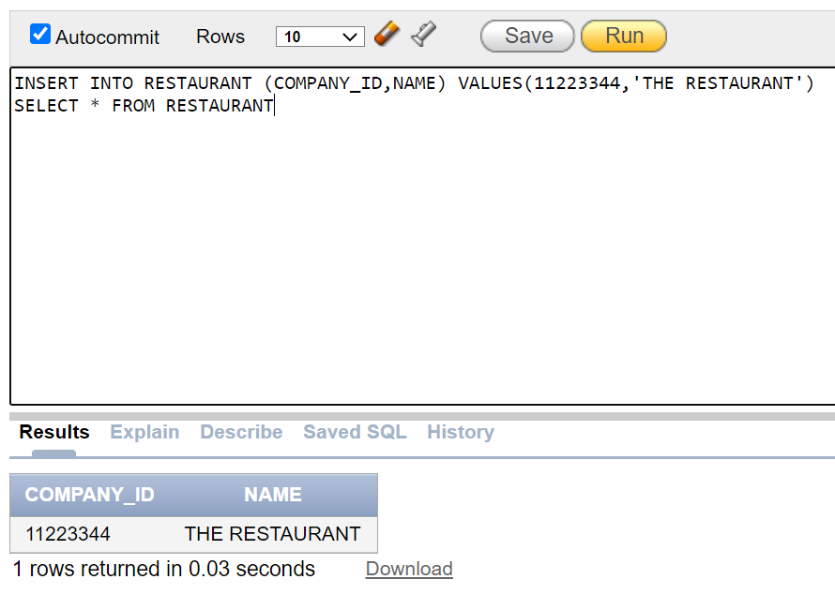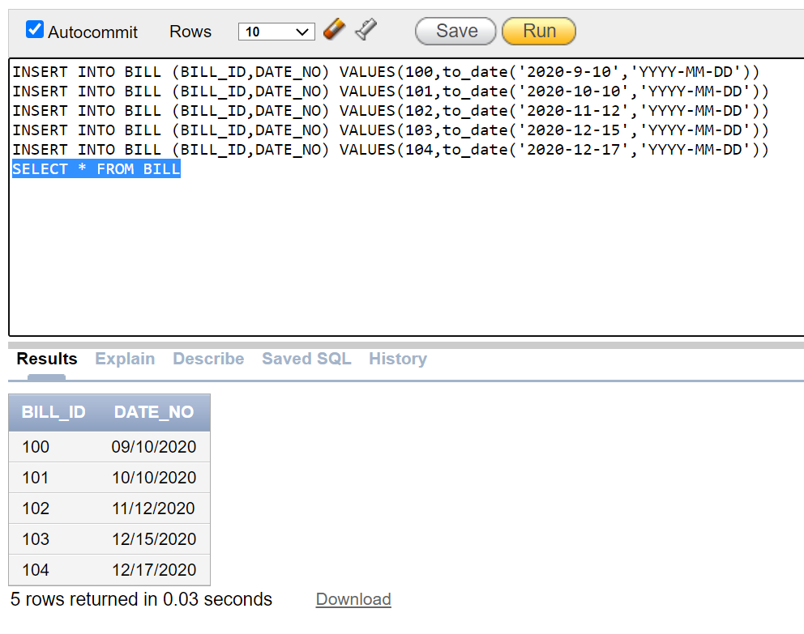

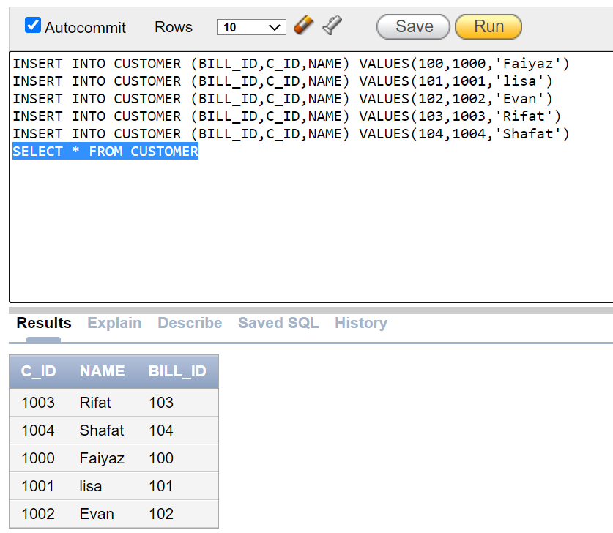

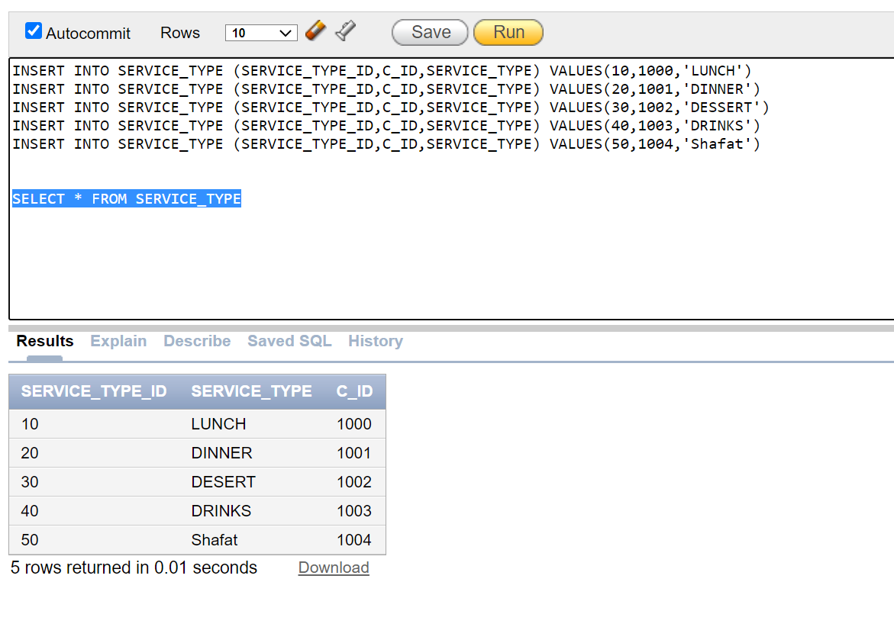

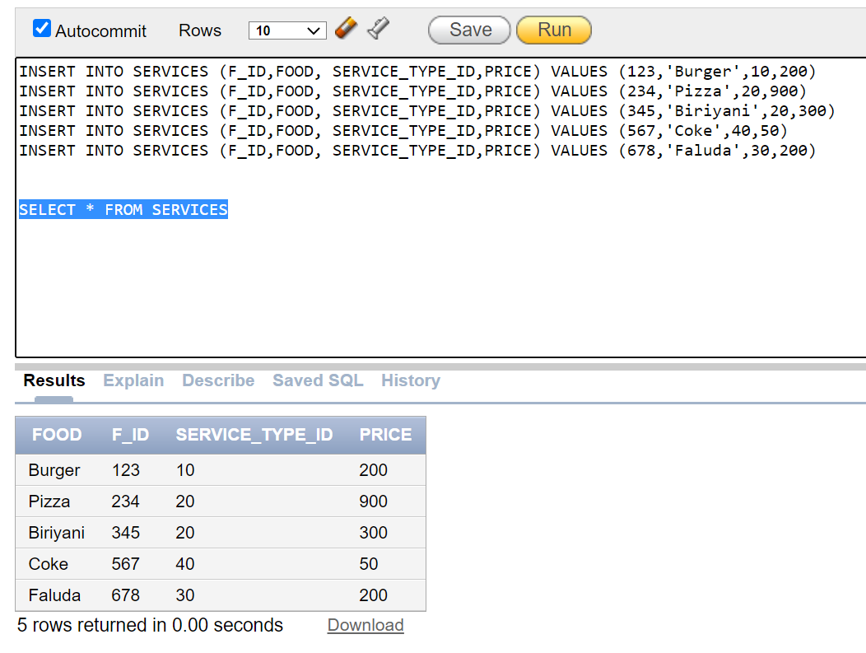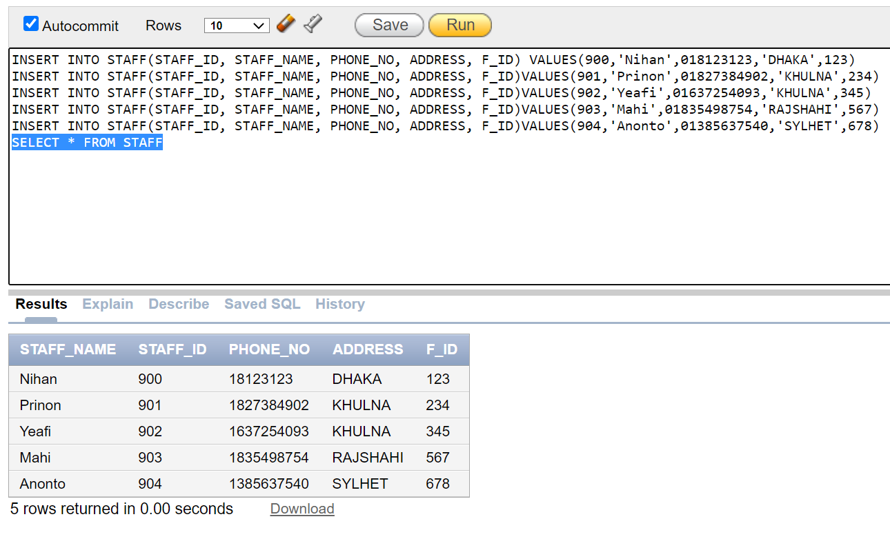

**Questions**

1. Get all the staffs who are from Dhaka

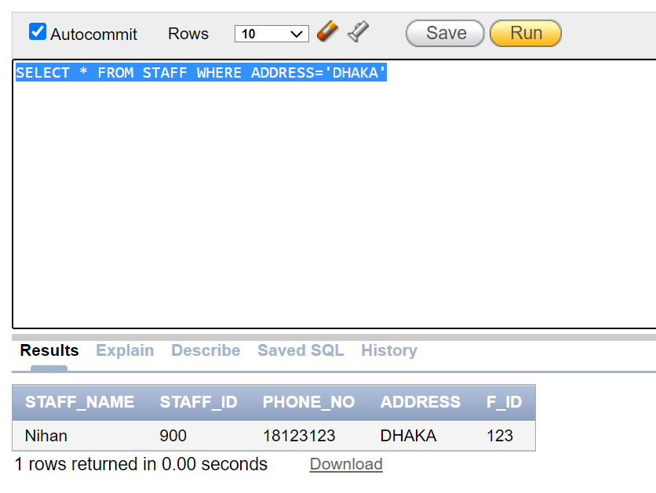

1. Get all the foods and their price in range 400

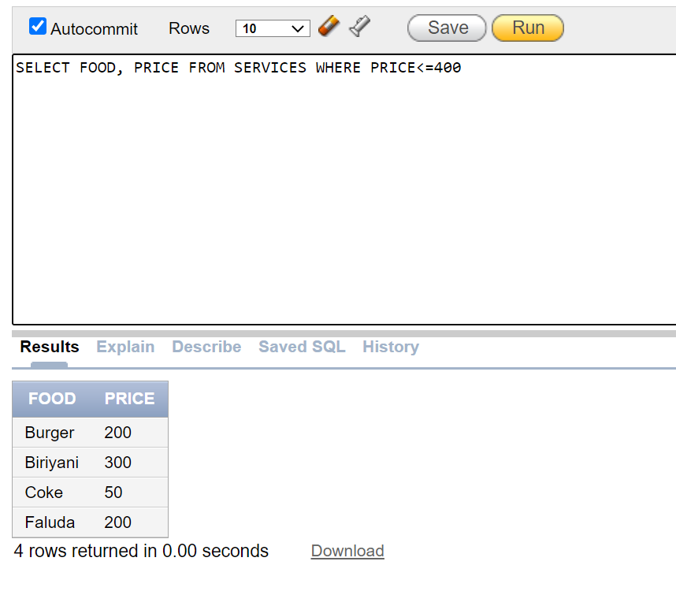

1. Get all the customer’s name in ascending order

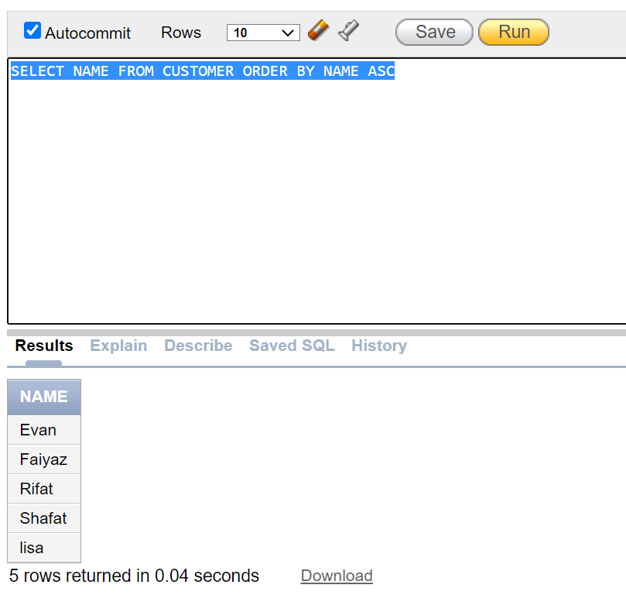

1. Get all food name, F_ID, Service_type_id where price is higher than 150

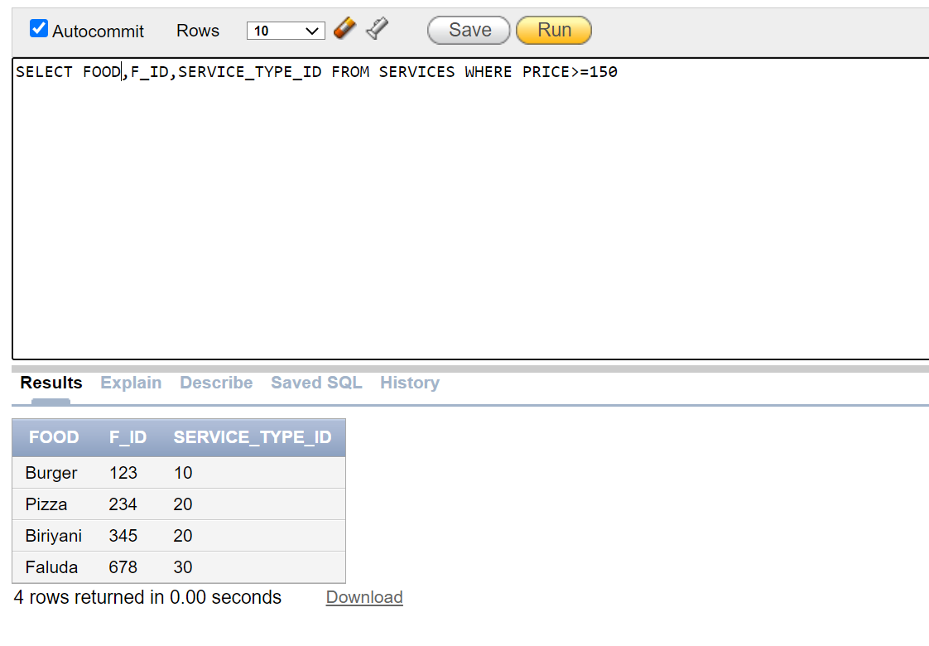

1. Get all details of customer who’s bill date is 10/10/2020

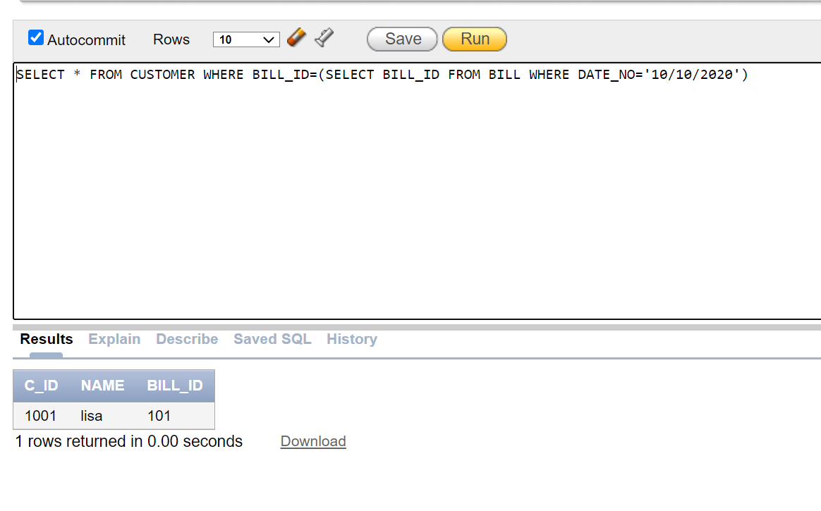

1. Get all data of service type taken by customer who’s bill is from date ’12/15/2020’

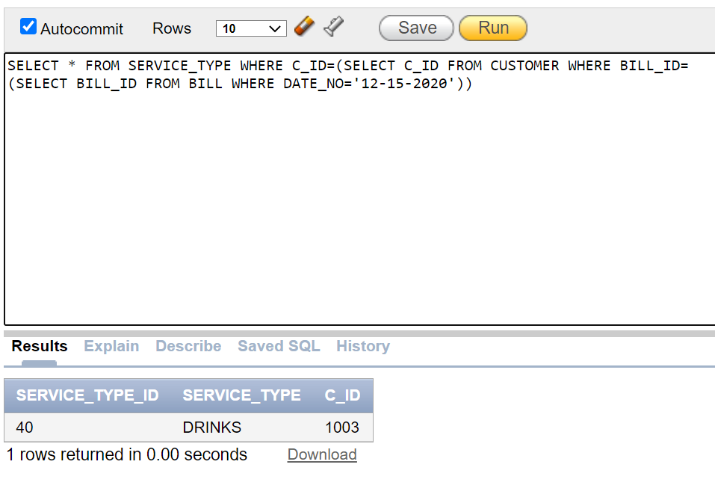

1. Get phone no and address of staff who served Pizza

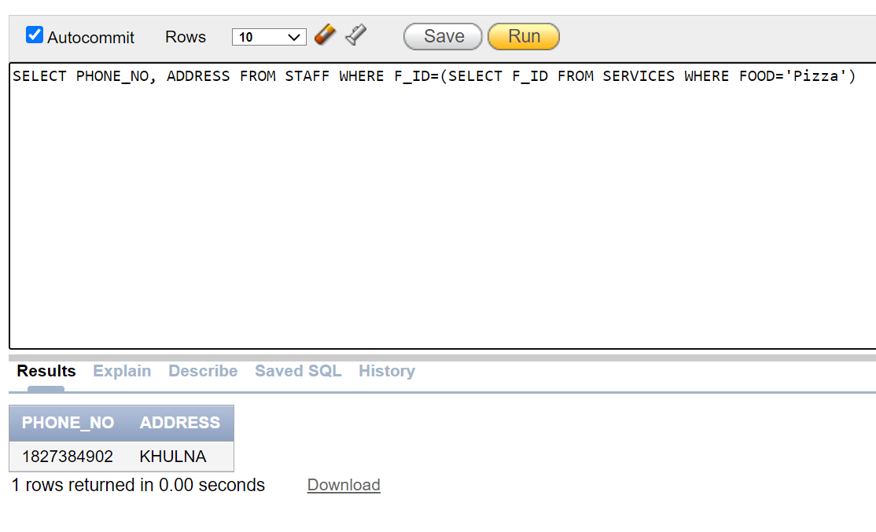

1. Write a query to display C_ID, customer name and

service_type_id?

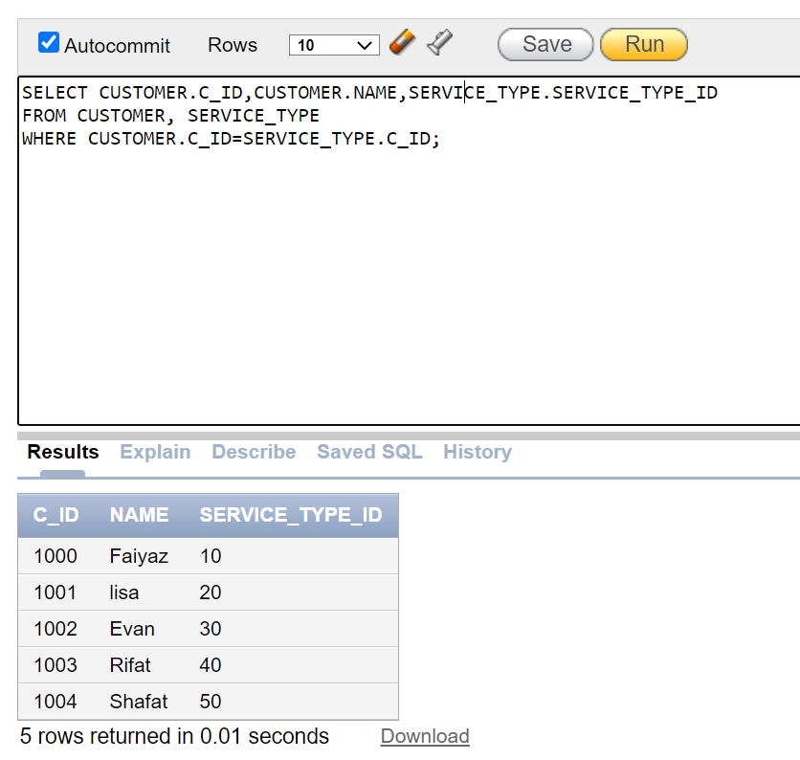

9. Write a query to display food, their staff name

and address

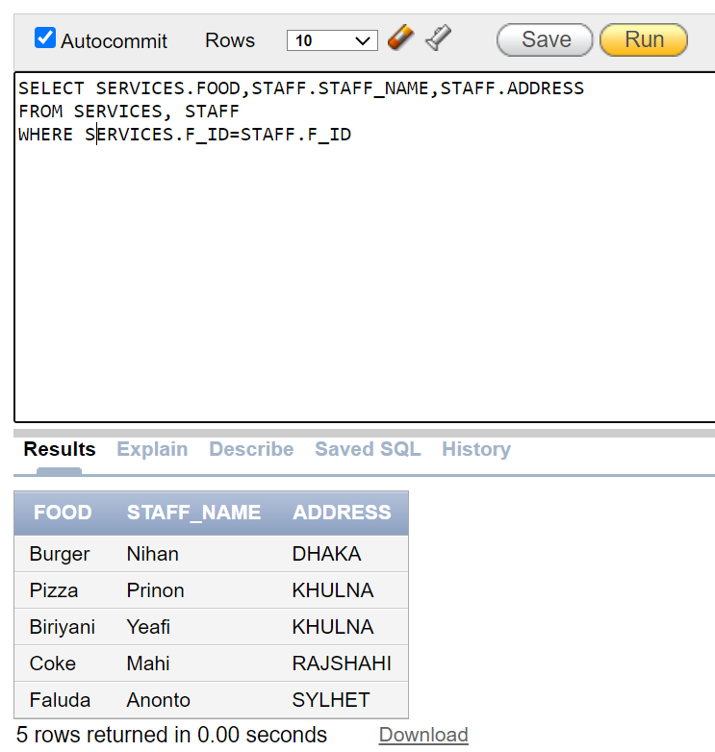

10. Write a query to display customer name and their bill date

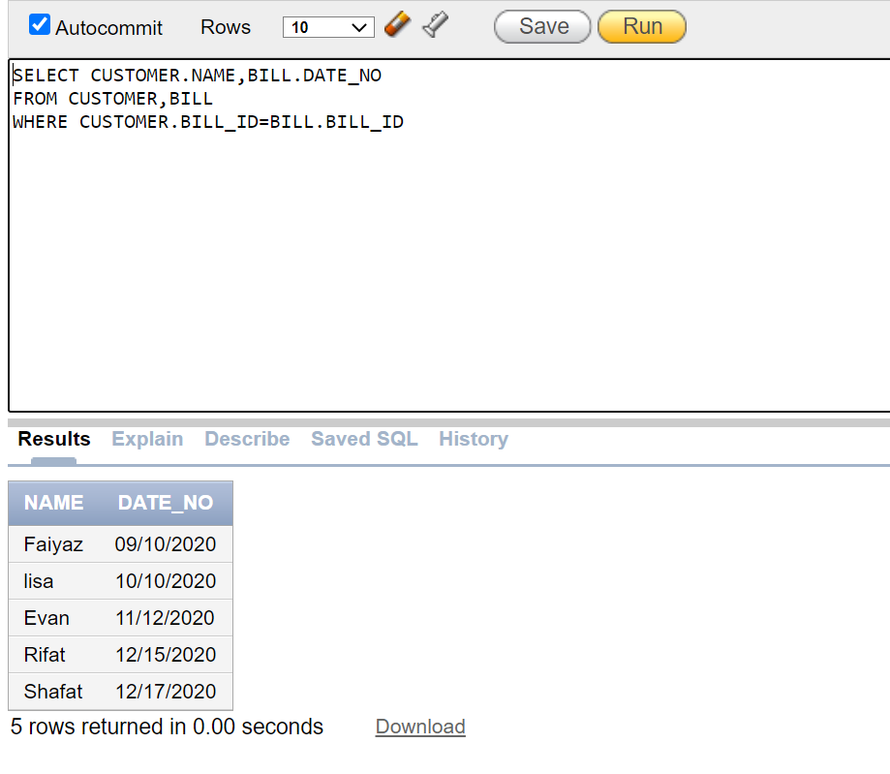

**Summarization:**

Restaurant management system is created by using Database management system to store the data of a restaurant. By using DBMS, we can easily access the data of any customers, staffs. So, it can be accessed by any user without losing so much time. However, for creating this system first, we have to make a scenario description about restaurant management system. Eventually, which helped us to create an Entity Relation (ER) diagram for this system. After that the normalization have been made by using ER diagram. So that we can easily decide how many tables can be made in this system. Nowadays every company or organizers uses the Database management system (DBMS) to store their data. This system also ensures the best security for all users. By using DBMS in restaurant management system, we can create an environment in which user have better access to more and better manage data. Such access makes it possible for users to respond quickly to changes in their environment. Now we face difficulties to know customers opinion on services. So In future, we can add an option for customer to give feedback of services and a comment option as a survey to improve overall service.